**Project Design Phase-II**

**Technology Stack (Architecture & Stack)**

|  |  |
| --- | --- |
| Date | 19 September 2022 |
| Team ID | PNT2022TMID21384 |
| Project Name | Gas Leakage monitoring & Alerting system for Industries |
| Project TEAM members | 19D114 – ARIKARASHRI. K  19D127 – NITHISH KUMAR. M  19D129 – RANJITH KUMAR. P  19D130 – RUTHRAM. M  19D135 – UDHAYAKUMAR. U |

**Technical Architecture:**

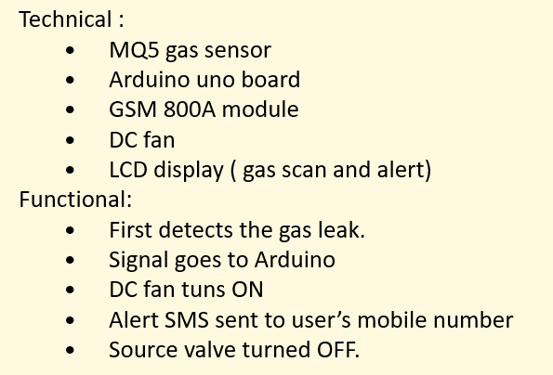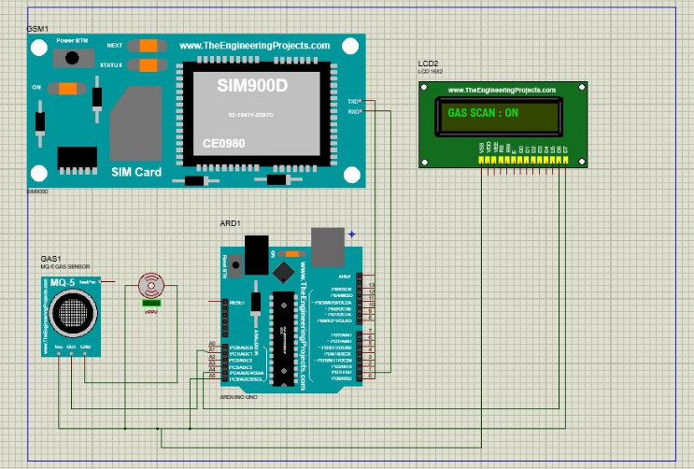

**DEVELOPMENT OF TASK ANALYSIS:**

**Hardware Requirements**

1) Arduino UNO Microcontroller

2) Green LED 1, Red LED 3

3) 9V Power supply (230V TO 9V STEPDOWN TRANSFORMER)

4) MQ6 Gas sensor

5) GSM 800 Module

6) GSM Sim

7) Connecting wires

8) Project base

**Software Requirements**

1) Arduino IDE

2) Language C++**WORKING:**

**Step 1**: A signal from the microcontroller will go to the display and show gas leakage message there.

**Step 2**: Simultaneously automatically turns on the DC fan to ventilate the leaked gas, and the source solenoid valve will be turns off

**Step 3**: Signal from microcontroller activates the GSM module and sends an alert SMS “ALERT GAS LEAKING” to the user’s mobile number.